

Blockchain Concepts and Technologies

MSc Cloud
National College of Ireland
Project Submission Sheet

Student Name: | Meenakshi
Student ID: | 24235415
Programme: | MSc in Cloud Computing
Year: | 2025
Module: | Blockchain Concepts and Technologies
Lecturer: | Sean Heeney
Submission Due Date: | 12th December 2025
Project Title: | ERC-20 and ERC-721
Word Count:

I hereby certify that the information contained in this (my submission) is information pertaining to research I conducted for this project. All information other than my own contribution will be fully referenced and listed in the relevant bibliography section at the rear of the project.
ALL internet material must be referenced in the references section. Students are encouraged to use the Harvard Referencing Standard supplied by the Library. To use other author's written or electronic work is illegal (plagiarism) and may result in disciplinary action. Students may be required to undergo a viva (oral examination) if there is suspicion about the validity of their submitted work.
Signature: | Meenakshi
Date: 12-12-2025
PLEASE READ THE FOLLOWING INSTRUCTIONS:

1. Please attach a completed copy of this sheet to each project (including multiple copies).
2. Projects should be submitted to your Programme Coordinator.
3. You must ensure that you retain a HARD COPY of ALL projects, both for your own reference and in case a project is lost or mislaid. It is not sufficient to keep a copy on computer. Please do not bind projects or place in covers unless specifically requested.
4. You must ensure that all projects are submitted to your Programme Coordinator on or before the required submission date. Late submissions will incur penalties.
5. All projects must be submitted and passed in order to successfully complete the year. Any project/assignment not submitted will be marked as a fail.
6. Please check that you read AI and Academic Integrity Acknowledgement Supplements in this document
Office Use Only
Signature:
Date:
Penalty Applied (if applicable):

Academic Honesty Declaration
I declare the following to be true for this submission:
- I have completed the task during the designated time window and declare it to be exclusively my own work.
- I have not received, or attempted to receive assistance in preparing this response from any other person during the assessment window.
- I have not provided, or offered to provide, assistance to any other student by any means during the assessment window.
- I have read and understand the National College of Ireland guidelines of Plagiarism.

Blockchain Concepts and Technologies
MSc Cloud Computing
CA1 Assessment
Smart Contract:
Once an e-agreement is being entered into the blockchain, it is there permanently. Instead of the legal practitioner or agent seeing to it that the compliance is fulfilled, the smart contract automatically undertakes all the provisions of the said agreement. It is put into computer code and functions according to unchangeable laws that are enforced when it's activated.
Ethereum:
Ethereum is a dispersed computing platform that works on the Internet, where is ownership and administration are distributed among millions of huge coalition pieces in an international actor setting, instead of the centralization in a company. The particularity of Ethereum consists in the fact that it eliminates the mediators. it uses unchangeable smart contracts located on the Ethereum network and unable to be changed or deactivated by any third party.
I will be using three platform for this assignment:
- MetaMask:
MetaMask is a digital wallet that lets us interact with Ethereum apps directly from browser. We can use it to store Ether and tokens, connect to websites and approve transactions. Whenever we will visit a decentralized app, MetaMask will pop up to ask if you want to connect. It also keeps our private key safe and give full control over funds.

- Remix:
Remix is a web-based application that allows one to create, test, and execute smart contracts on the Ethereum blockchain. It works like a coding lab, embedded in a web browser. Local installation is not needed, and the users only need to access the site to begin development. Remix also has the ability to support the Solidity programming language, the main language used to create Ethereum contracts and save files with the “.sol” file extension. The site offers instant response to contract code.

3.Pinata:
Pinata is a platform that assists in storing files in a decentralized system called IPFS (Interplanetary File System). Unlike the traditional centralized storage systems which store the media assets such as images, videos and documents in one computer server, IPFS spreads the media assets across a large number of computers, making them less prone to loss. To this end, we use Pinata to store NFTs, where the digital art is stored on IPFS before being minted through smart contracts which refer to the IPFS file.

Part One : Practical Assignment ERC-20:
- Smart contract written in Solidity
- 200 tokens created
- Deployed on Ethereum test network
- Tokens distributed to 4 wallets
• Transactions verified on Etherscan

Contract
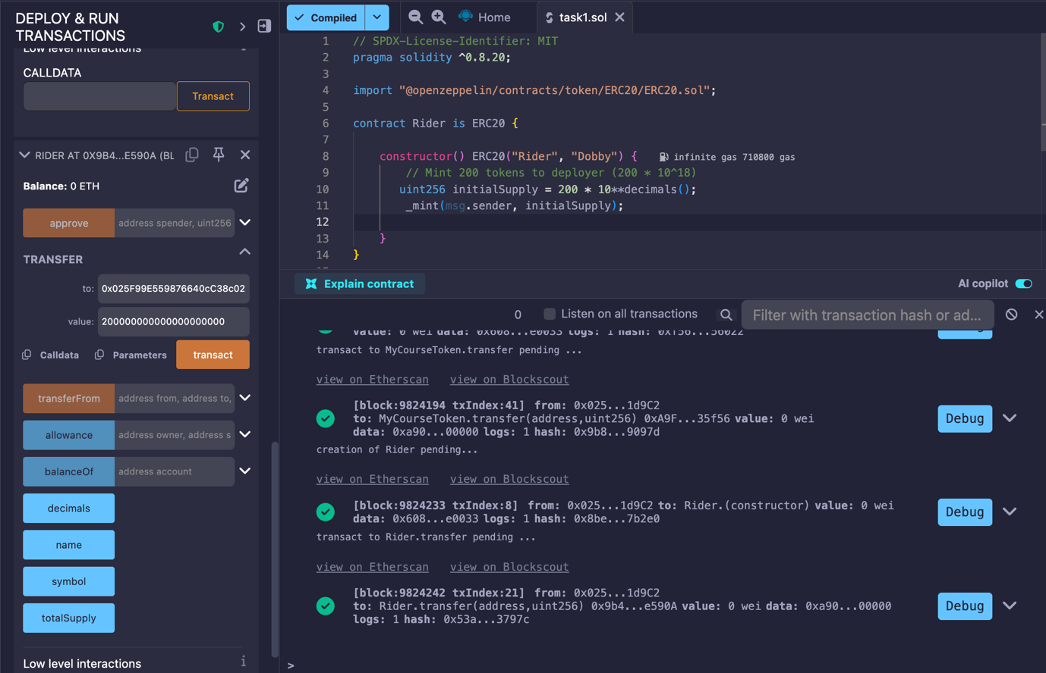
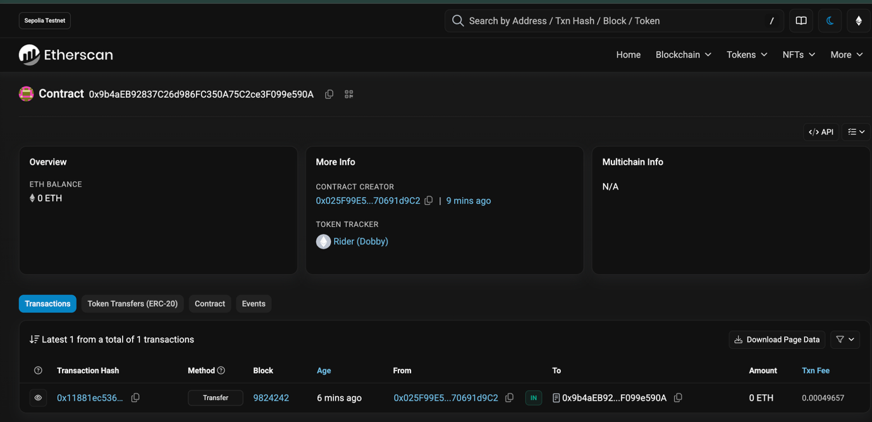
Transactions:
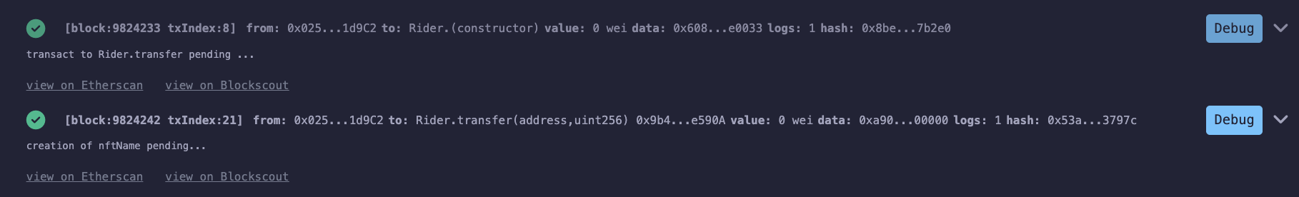
Four Wallet mint and transfer record:
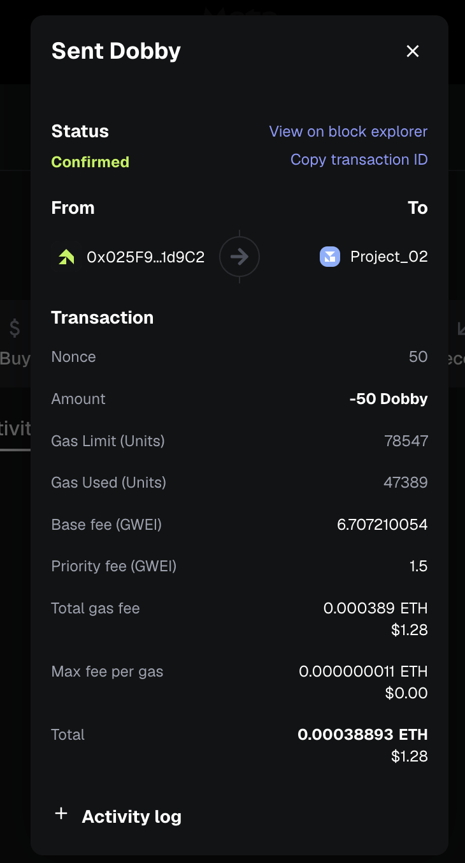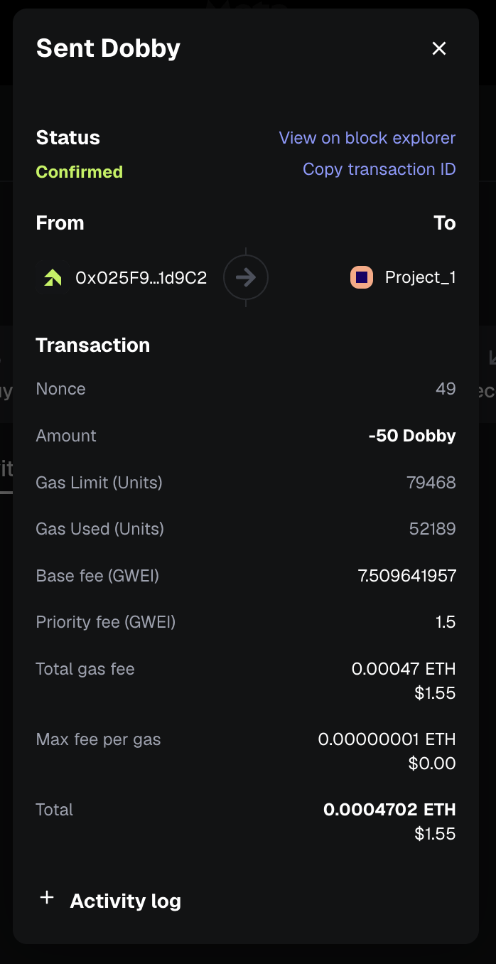

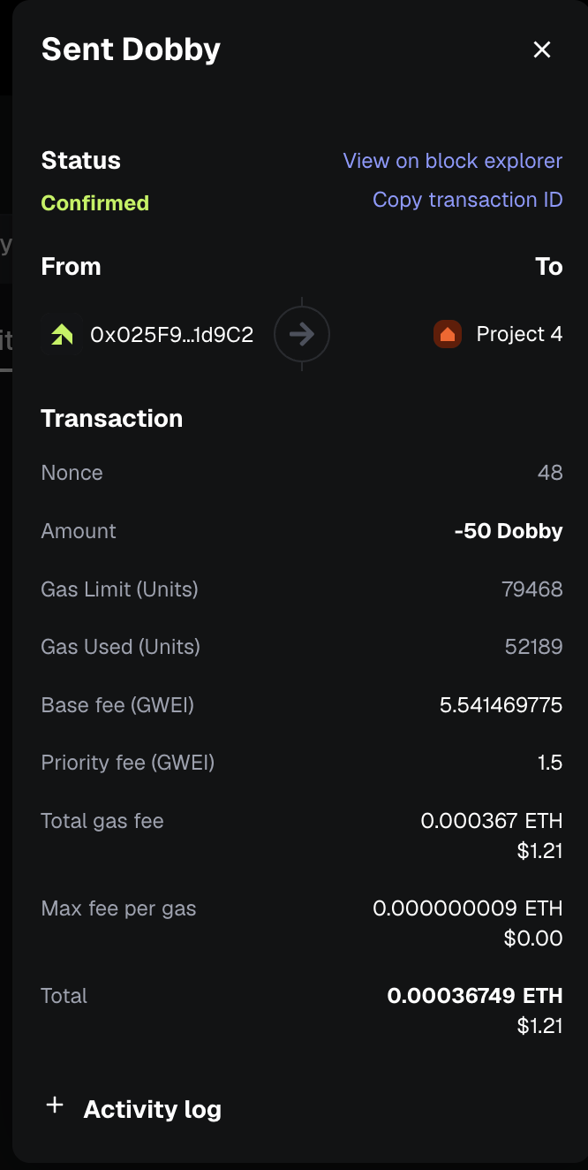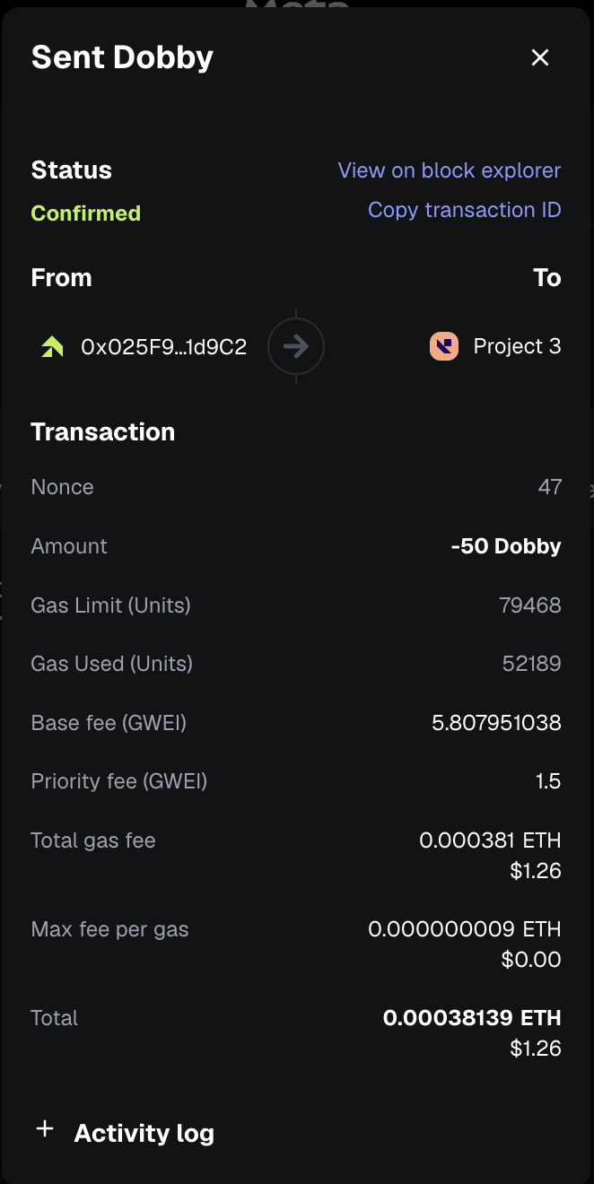
Part Two: Practical Assignment ERC-721:
This deployment and the ERC-721 contract created an ERC-721 contract called Compliance Certificate that connected to the IPFS via Pinata to store metadata of the certificate, after which one deployed using the injected provider MetaMask test network, and then four certificate tokens were minted to four different wallet addresses.

Procedure

- Smart contract using ERC‑721 standard
- NFT linked to a digital asset
- Asset stored on IPFS
- NFT minted and sent to 4 wallets
• Verified on Etherscan
Contract: 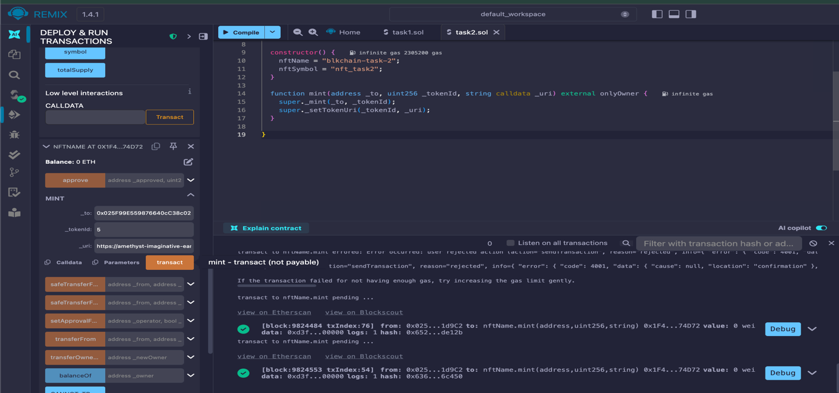
Transaction
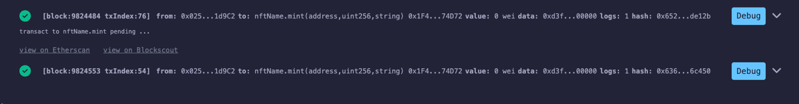

Ehterscan view:
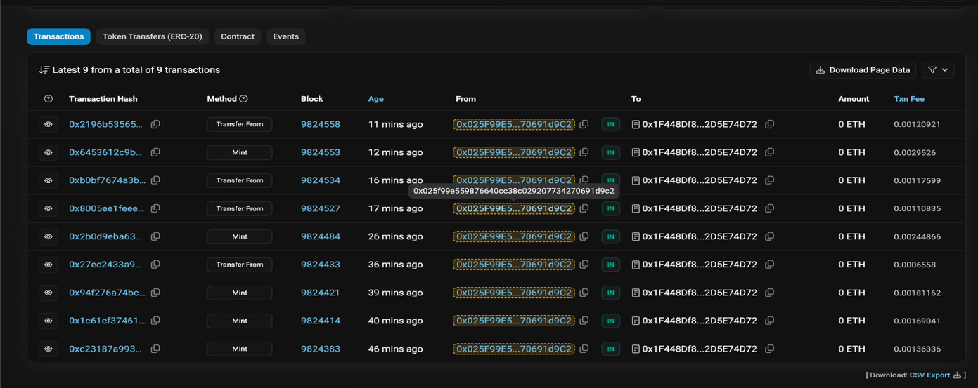

Wallets Distribution:
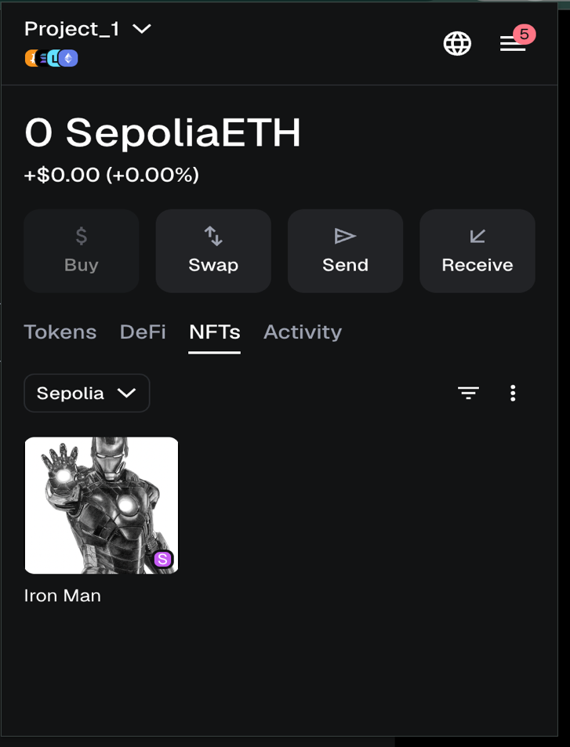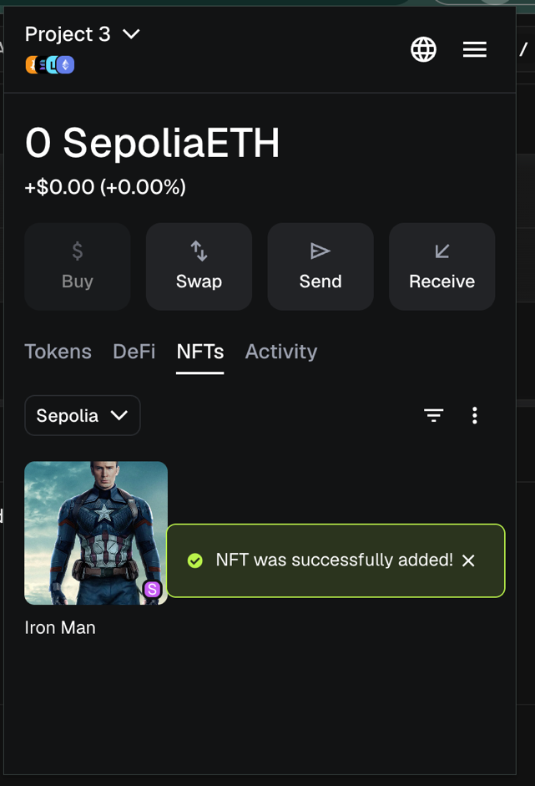

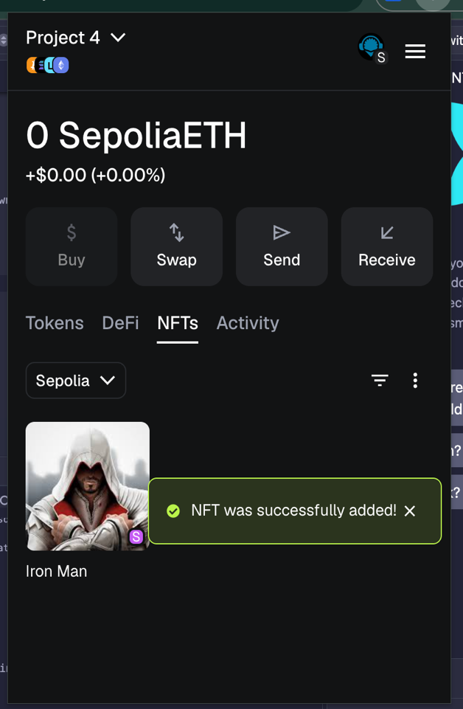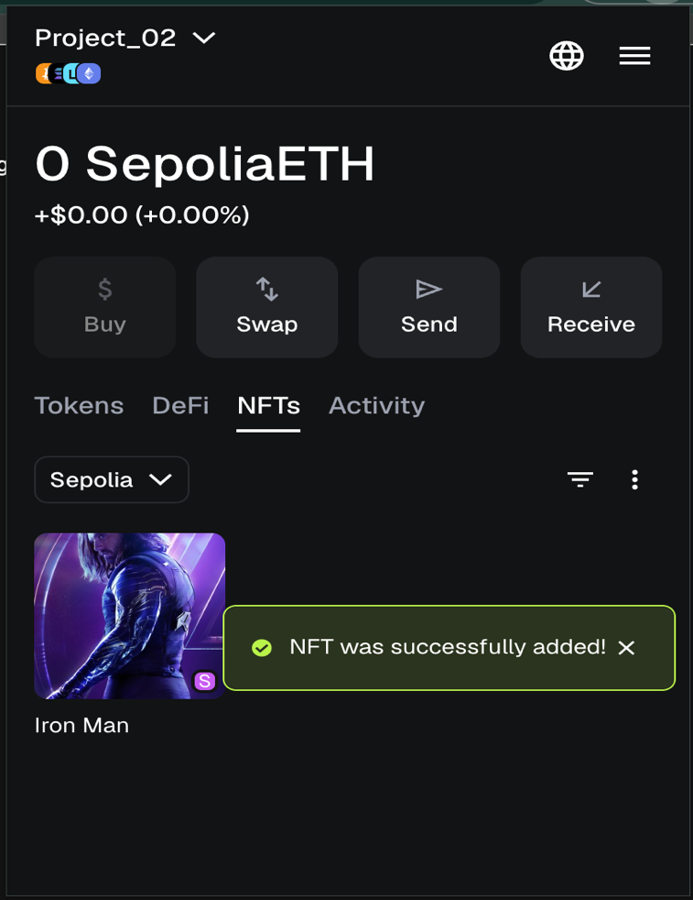

Transaction Hash all four transfer

1 - 0xc23187a9933ce557d37cd3c255ac9e3df458d58f1dd534fc0b90c3d1ef1b72f7 0x27ec2433a962377a2bfebcf705d4a9f36322dd1bde5ab4db0395f9d5111c550a

2- 0x94f276a74bc02165c2b949c5f635b0b80a3c01e717bf2b00d133fd945d4aa09c
0xb0bf7674a3b314dd6b8caaa98731718cf936a316a2c7812262a043ff1f76b0f9

3- 0x2b0d9eba63364317f2fad3af57233979130f8cb48ad0d5ea8490770616728e10
0xb0bf7674a3b314dd6b8caaa98731718cf936a316a2c7812262a043ff1f76b0f9

4- 0x6453612c9b2fa2a1a4ab7949ba8d2fb785d18c399f0e03bdb6abdd1f3dc2d785
0x2196b535650d409fa6de5cb3fd71e98d0cff6c59f97f165b5433585b4927454c

Part Three: Theoretical Assignment
Healthcare – Secure Patient Data and Clinical Coordination (Patientory‑style model)

The current state of the medical industry is faced with a major issue related to the way patient information is managed. This information is widely spread between various hospitals, clinics, and insurance companies. This creates a challenge in sharing information effectively and efficiently. There are also concerns related to privacy leakages that occur through the reproduction of information in various places.

One of the solutions to this issue would be the implementation of blockchain technology, such as that employed by Patientory. This solution would mean that patient data is actually not stored on the blockchain. Instead of storing data, it would register the respective metadata about who accessed or altered a certain record, as well as the precise time of such an event with high accuracy. It would be kept encrypted in the internal database of the respective hospital, while any data access or alteration would be cryptographically recorded on a patient's respective record in the blockchain.

Smart contracts add more features to this framework by incorporating automated and self-enforceable logic that makes it intelligent enough to manage access permissions, actions, and other issues related to compliance automatically without human intervention.Smart contracts automatically govern who is permitted to view a given set of records for a certain amount of time. A doctor could be given permissible access to the cancer treatment history of a patient for a certain amount of time, and automatically lose that access after completion of the treatment. If new test results are entered, it would automatically alert the patient through the blockchain network that it is from an authorized source.

Benefits: It is apparent that there are some great benefits here: less need for repeat tests, quicker distribution of information, and greater security for avoiding information spillage. It could also positively influence medical research by ensuring that information is not compromised in any way, especially for trial medications. However, there could be drawbacks too. It is difficult to connect older systems for storing patient data into newer technology, and not everyone would be ready to forgo their own control. Even with just a small amount of information for identifying a patient, information security could be compromised if it is not managed carefully. There could also be some issues with authority.
Ultimately, the use of blockchain technology is capable of ensuring that security and transparency are achieved in the management of health information. However, it does not provide solutions for some of the issues such as incorrect information, lost data, or a lack of investment in health information systems. It is actually important for the involved health institutions and patients to understand that shared governance of the system is important for trust to be gained by both parties. This would make the health system more effective or it could just become a complicated mess that doctors would complain about.

Supply Chain / Manufacturing – End‑to‑End Traceability (Walmart & IBM Food Trust‑style model)

Today, there are many people and businesses involved in a supply chain, such as farmlands, factories, transporters, stores, or rations. Normally, they would maintain separate data reporting via emails or online platforms. This would sometimes become problematic since there would not be one source of the truth, making it difficult for any issues that occur to determine where it happened and for what reason.
A blockchain solution would provide the answer to this issue. In this process, each unit of produce, such as a crate of leafy vegetables, is given an unique digital identifier so that it is traced through the supply chain. Each time it is transferred from the farm to the factory through the store, it is recorded in one shared digital record ledger. All parties involved get access to this information, which cannot be altered later. If any issue is observed by the store, such as corruption of produce, it gets traced back to the point of origin in mere seconds, not days.
Smart contracts make it all that process smooth. Payments can automatically be made if goods are delivered on time and reach the desired temperature. If there is a lag or the temperature is not suitable, the system automatically sends notifications for that very moment. Since everyone shares the same information, it is easier for one to establish liability in the event that something is wrong.
However, there are some issues with this. Smaller farmers or providers do not necessarily have good internet or a box to use this blockchain. Furthermore, if things are entered incorrectly, the issue is still recorded anyway, it does not correct for human error. At times, larger companies get more of the say in what is allowed for the blockchain.
Blockchain makes supply chain, more trustworthy, more easy to track. It facilitates understanding what happened to a good, where it came from. However, for it to be fair for everyone involved, they must reach a consensus on standards and divide the cost of this technology so that small businesses can participate.

Insurance / Finance – Parametric Crop Insurance for Smallholder Farmers (Lemonade‑style model)

The classic crop insurance often takes a long time, with high costs because the claims assessment is done manually. This is a problem for small farmers in developing nations, as the value of each policy is small, with high costs.
The parametric insurance provides a simpler and faster way to address the problem. The system is programmed to pay the farmers, as opposed to the traditional assessment, once certain measurable events occur, such as when there is insufficient rainfall within a specified time.
In this arrangement, a farmer purchases an insurance policy via a mobile phone application. The cost, terms of receiving the money, and the wallet address of the farmer are encoded in a smart contract on a blockchain. Weather conditions obtained from satellites, sensors, or weather stations are submitted to the smart contract via other reliable services known as oracles. If the conditions indicate that rainfall is below a certain threshold, the system provides funds to the wallet of the farmer.
Since everything happens Automatically, there is no need to fill out claims and make a visit to the field. This makes it cost-effective and even possible to insure smallholders en masse. This is also because Farmers receive compensation for their crops quickly, which helps them purchase seeds or compensate for the cost summer when there are no crops. The block-chain ledger is also transparent, providing a transparency check on how the funds were paid.
On the other hand, this model also brings different challenges. For instance, in cases where the weather information or thresholds are not a true reflection of what is happening on the ground, farmers, although they have suffered a loss, may not get any payment. There is also a high likelihood that the oracle might fail, which may result in incorrect disbursement of payments. Other farmers might find it difficult to use the digital wallet or protect the private keys.
In conclusion, a parametric crop protection offered via a blockchain structure has been argued to make crop protection faster, cheaper, and more transparent for small farmers. The eventual success of this product, though, is dependent on a system that is fair, reliable, and understandable.

Construction / Infrastructure – Tokenised Project Funding and Immutable Documentation (BuildCoin‑style model)

Construction projects are very complex in that they encompass numerous contracts.
Payments and approvals: “Disagreements over delays, cost overruns, or the quality of work are often inevitable, and related documents for projects end up dispersed among various parties. A blockchain-based system, like the one proposed by the BuildCoin model, would store funding information for projects into a centralized digital ledger that is collectively trusted by everyone.”
However, the system also allows for the segmentation of a project into tokens, which are purchased by the investors. A good example of such a project is the housing scheme, in which the whole building is digitalized in the form of tokens, and any person who purchases the tokens is entitled to ownership of the project. This is reflected in the form of ownership of the tokens as well as the money in the blockchain. Smart contracts can also spend funds for certain work that is verified by inspectors, sensors, or authorities. While doing this, it accelerates the disbursement of funds by minimizing paperwork.
Storage of important documents such as blueprints, permits, and inspection reports for projects can also be achieved through the help of the blockchain. It is important to note that the documents could be stored outside the blockchain, but its “fingerprint,” or “hash,” is what is actually recorded on the blockchain. Should the document be altered later on, it would no longer be the same since its hash would no longer be the same either. This is very beneficial in relations to conflict resolution since everyone would know what the original looked like.
On the other hand, some of the advantages of this system include more clarity, rapid funding, as well as better evidence for legal matters. This could work wonders for developing nations that often face corruption or incorrect recording of funds for various projects.
Despite being this, there remains a challenge. Such projects that use tokens could fall under the auspices of security laws, meaning that a lot of regulation is involved. Smart contracts could also rely on trusted parties such as a building examiner or an engineer who would ensure that work is done. These systems could end up adding to the complexity of systems that manage projects.
Nevertheless, if adopted wisely, this tool could ensure that construction funding becomes more open and more democratic, as it would enable communities to contribute to it directly and monitor the progress of projects initiated by their communities in real-time. However, it would work effectively only if it were managed with good governance.

Part Four: Presentation
​YouTube link: Link

